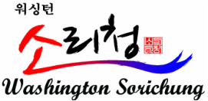
WASHINGTON SORICHUNG

is an organization dedicated to the cultivation of Korean classical music and other Korean traditional arts. It was found in 2007 by Director Eunsu Kim and has branches in Fairfax and Virginia Beach, Virginia.

Our mission is to promote Korean traditional music in Washington DC metro area through education, performances, and cultural enrichment programs. This mission extends to Americans with an interest in Korea, Koreans living in the United States, and the children of Korean immigrants who wish to rediscover their heritage.
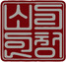
Through events in schools, Sorichung provides American students with exposure to Korean culture. As part of U.S School Tour Project, Sorichung has toured schools to bring primary, secondary, and university students the experience of Korean traditional singing, instruments, and dancing. As an extension of its educational mission, Sorichung provides these educational programs to adult audiences sponsored by the Korean Cultural Center in Washington DC, the Korean Embassy, Korean Heritage Foundation, and the Korea Foundation.

Sorichung serves the community by providing the highest quality education in Korean traditional arts possible and giving its students access to professional-level performance opportunities. Sorichung features instruction in Pansori (Korean traditional singing) and other Korean traditional arts such as Samul-Nori (percussion), Gayageum (a string instrument), and Korean traditional dancing. Sorichung also facilitates exchanges with teachers from Korea to give students the opportunity take lessons from other outstanding musicians. Also, as of 2014, Washington Sorichung is a Certifying Organization for the President’s Volunteer Service Award (PVSA) in the U.S.

Sorichung’s members give regular performances at venues such as the Kennedy Center, the Smithsonian, the Library of Congress, and colleges around the country, such as Williams College and the University of Maryland. Sorichung students also compete in international competitions, such as the annual World Korean Traditional Performing Art Competition. Through these activities, the over eighty members who make up Sorichung spread the enchantment and joy of Korean traditional music in America.
| Performances |

2008 New York Town Hall, NY ‘Korean Traditional Opera, Bhang Jah Jhun’
2008 Kennedy Center, DC ‘The 5th Korean Cultural Gala’ in Celebration of 8.15
2009 George Mason University ‘The 1st Washington Sorichung Pansori Recital’
2011 Williams College, MA ‘Pansori Workshop for Roomful of Teeth’
2011 Library of Congress, DC ‘Asian Pacific American Heritage Month’
2012 Korean Ambassador’s Residence, DC ‘Woman Society for Seoul’
2013 Union Station, DC ‘The Biggest Painting in the World 2013 Exhibition’
2013 Kennedy Center, DC ‘Asian Americans and Pacific Islanders Heritage Month’
2014 George Mason University ‘Second Concert with Korean Human Cultural Asset’
2014 Dominican Republic ‘The Foundation Day of Korea’s Cerebration performance for Korean Embassy of Dominican Republic’
2014 Dominican Republic ‘Dominican Republic’s CER-TV Channel 4, a live broadcast for Korean Traditional Performance’
2015 Williamsburg, VA The National Unification Advisory Council Washington Chapter ‘Human Rights in North Korea and Peaceful Unification’
2015 Soricha Tea and Theater, VA ‘Soricha Tea and Theater Grand Opening’
2016 Washington, DC – Special performance at The White House
Chapter ‘Human Rights in North Korea and Peaceful Unification’
2015 Soricha Tea and Theater, VA ‘Soricha Tea and Theater Grand Opening’
2016 Washington, DC – Lunar New Year Performance at The White House

| Awards |

2007~Present Student participation and awards in performances in NY, IL, LA, NJ, etc
2009-2015 NY ‘World Korean Traditional Performing Art Competition’ 1st Place Student Award
2013 IL ‘2013 Christian Music Festival at Chicago’ 2nd Place Student Award
2014 The Korean American Association of Virginia Appreciation Plaque
2014 ‘President’s Volunteer Award- Gold’
2014-2015 LA ‘Korean Traditional Music and Performing Art Competition’ 1st Student Award
2015~Present Monthly Performance at Sorichung & Soricha Theater
2016 ‘The KoaLife Magazine January Edition Interview’ and WKTV Broadcasting Station

Dear Friends,

On behalf of Sorichung Enterprise LLC, Washington Sorichung is pleased to announce the 10th Year Anniversary Performance to be held on September 3rd, 2016 at George Mason University in Northern Virginia.

The 10th Year Anniversary of Washington Sorichung showcases the success of the past ten years and will be celebrated through talented music and dance performances by traditional Korean artists, samulnori, pansori, and arirang performaces. This is truly an event of culture that will related to all ages and backgrounds.
Our marketing and outreach campaign includes a very strong, interpersonal movement. We use local blogs and social media sites including Facebook and Youtube, as well as mailing list mass emails. As a truly collaborative event, the 10th Year Anniversary Performance is financed with sponsorships from area businesses, contributions from the community, donations, and ticket sales from the performance. Please join this mutually beneficial effort by becoming a sponsor today!

WHY BECOME A SPONSOR?

By sponsoring Washington Sorichung’s 10th Anniversary GMU Performance, you will get unlimited exposure to hundreds of residents throughout the Northern Virginia area, the mass student population at GMU, as well as the local Korean American community. Our sponsorship levels and benefits are presented in the enclosed package. We have chosen George Mason University as the primary location for significant exposure and impact.

We invite and encourage you to become a sponsor of the Washington Sorichung 10th Anniversary GMU Performance. In order to ensure that your business receives the appropriate recognition and to meet our publicity and promotion deadline, we kindly ask that you respond no later than August 15th, 2016.

Visit www.washingtonsorichung.org for more information on our organization, or contact us at washingtonsorichung@gmail.com for any further inquiries. We look forward to receiving your valuable support, highlighting your business, and enhancing our community through your contribution!

*Ad submission deadline is August 15th, 2016. Ads must be submitted as a high-solution PDF, full size 8”x5.5”, half size 4”x5.5”, or business card size 4”x2.5”. E-mail to washingtonsorichung@gmail.com*

Sincerely,

Eunsu Kim
Director, Washington Sorichung,Korean Traditional Music Institute
©Sorichung Enterprise LLC.

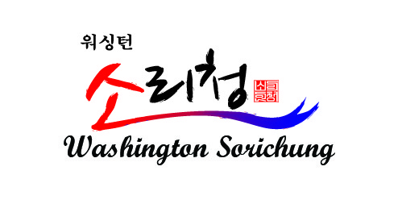
Gyeonggi Provincial Dance Company from Korea and Washington Sorichung,US
10th Year Anniversary Performance
Advertisement Sponsorship in Concert Program Book
Washingtonsrichung.org

Sponsorship levels are divided to Gold, Silver, and Bronze, and are $500, $300, and $200 respectively. Sponsorship benefits are listed below.

*Ad submission deadline is August 15th, 2016
*Ads must be submitted as a high-resolution PDF file.

Please email washingtonsorichung@gmail.com for any questions or inquiries.
Make check payable to ‘Washington Sorichung’ and mail it to the address below
7112 Columbia Pike., Annandale VA 22003 / T: 703-642-0020

Gold Level ($500):
- Full page advertisement on
concert pamphlet (8in x 5.5in)
- 6 Available

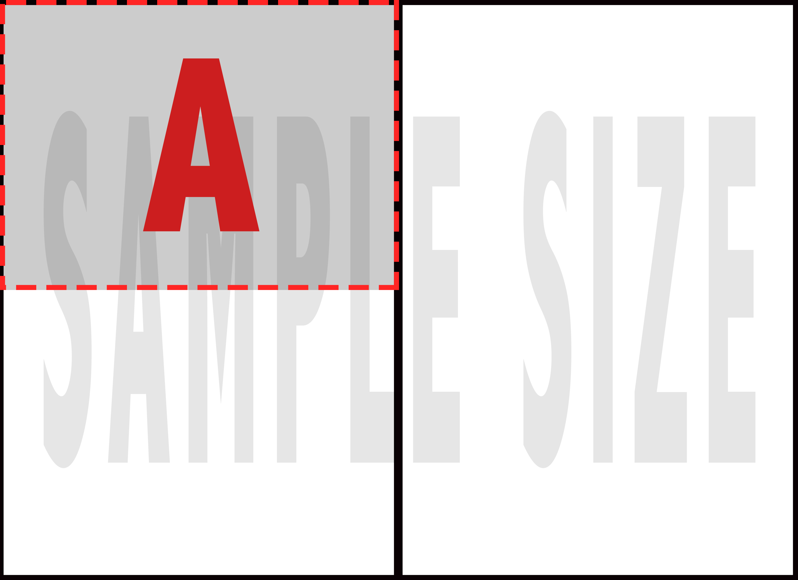
Silver Level ($300):
- Half page advertisement on
- concert pamphlet (4in x 5.5in)
- 8 Available

Bronze Level ($200):
- Business card advertisement
on concert pamphlet (4in x 2.5in)
- 10 Available

2016 WASHINGTON SORICHUNG 10th YEAR CELEBRATION

Gyeonggi Provincial Dance Company, Korean Traditional Dance Performance&
Washington Sorichung, Korean Traditional Music Pansori and Minyo

For the past ten years, Washington Sorichung has spread the beauty of the Korean culture within the Northern Virginia area through performances and programs centered on the heritage and history of Korea. As the special occasion of Washington Sorichung’s 10th Year Anniversary is coming up, we are honored to have partnered up with the nationally acclaimed Gyeonggi Provincial Dance Company from Korea to showcase the biggest event of the year. The musical festival will be characterized by traditional performances from top musical Korean performers within Gyeonggi Provincial Dance Company and Washington Sorichung.

The traditional Korean performances by the Gyeonggi Dance Company that will highlight the Korean Festival for our 10th Anniversary celebration are Buchaechum ‘Fan’ Dance, Dongnae Hakchum ‘Crane’ Dance, Janggochum ‘Hourglass Drum’ Dance, JindoBuk ‘Jindo Drum’ Dance, Salanga Dance, Yukkdong ‘Dynamical’ Dance, and Nongakmu Dance. The Washington Sorichung team will be performing Pansori and Minyo Dance.

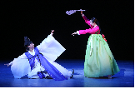
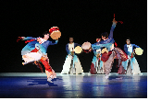
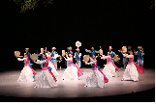
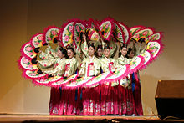

Location:
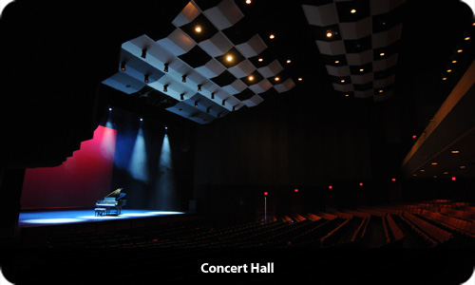
Harris Theatre at George Mason University
4373 Mason Pond Dr, Fairfax, VA 22030

Date/Time:
September 3rd, 2016
6:30 PM – 8:30 PM

Ticket Price: $30 each

Organizer:
Washington Sorichung,
Korean Traditional Music Institute
Sorichung Enterprise LLC
Gyeonggi Provincial Dance Company

Sorichung Enterprise LLC
Sorichung Enterprise LLC is a Korean Cultural Agency in the Washington DC area that operates Washington Sorichung Korean Traditional Music Institute and Soricha Tea House, Korean Traditional Tea Shop and Cultural Theatre. As an educational and artistic organization, we educate people on Korean traditional music, regularly invite Korean traditional artists for workshops, and provide Korean traditional tea for a vibrant Korean traditional arts community.

Gyeonggi Provincial Dance Company
Established in 1993, the Gyeonggi Provincial Dance Company is representative of Korean traditional dance serves as a leader in the development and refinement of the art. The organization is particularly noteworthy is the company's unique blend of traditional and modern Korean Dance.

